

SECTOR ON CAMPUS PROJECT
DATA ANALYSIS AND VISUALIZATION REPORT: STREAMING PLATFORM
Submitted By: Batuhan Denizli [43948131788]
Department: Statistic
Project Components:
- Data Warehouse Design (Star Schema)
- SQL Data Analysis & Metrics
- Interactive Tableau Dashboard
Date: May 2026

Data Warehouse Architecture (Star Schema)
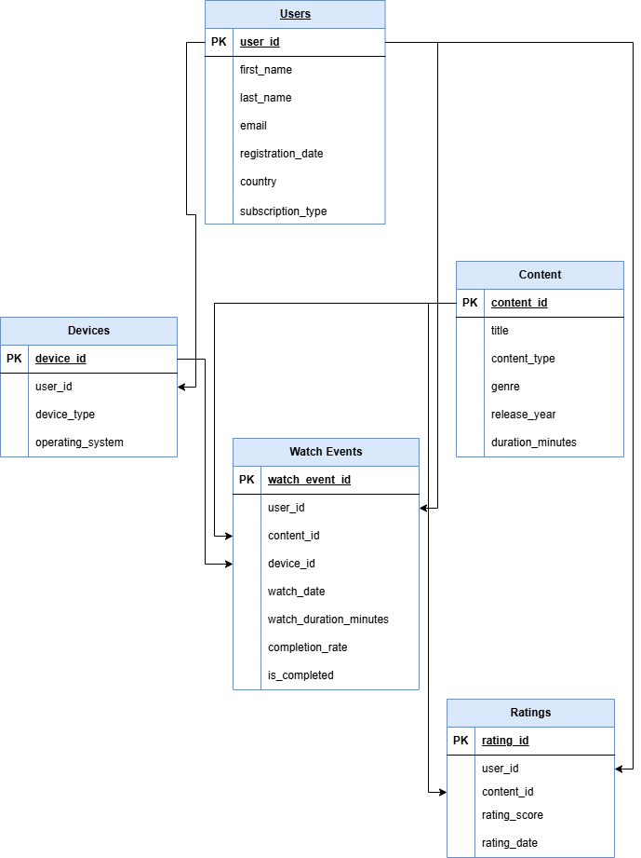

Data Warehouse Architecture and Table Relationships
In this project, a Star Schema data warehouse architecture was implemented to optimize the data analysis and reporting processes. This structure significantly improves query performance and ensures faster data processing in business intelligence tools like Tableau.
1. Fact Table (Central Table)
- Watch_Events: This is the core of the system. It stores all quantitative metrics (e.g., watch durations, completion rates, watch dates) and transactional events that occur on the platform. The vast majority of the analytical calculations are based on this table.
2. Dimension Tables These are descriptive tables connected to the central Fact table, providing context and enabling data filtering/grouping:
- Users: Contains demographic details of the users (e.g., country) and their subscription plans (Basic/Premium). Connected to the Fact table via the user_id key.
- Content: Holds specific details about the media, such as genre, release year, and total duration. Connected to the Fact table via the content_id key.
- Devices: Stores information regarding the hardware (Smart TV, Smartphone, Laptop, etc.) and operating systems used for streaming. Connected to the Fact table via the device_id key.
- Ratings: Contains the scores given by users to specific content. This is integrated into the data model to measure content quality and user satisfaction.
Relationship Model: All Dimension tables are linked to the Watch_Events table using a One-to-Many relationship architecture (Primary Key -> Foreign Key logic). This relational structure allows for seamless and lossless data joining, enabling complex queries such as "watch durations by subscription type" or "device usage distributions.

6.3 SQL Data Analysis & Key Performance Indicators (KPIs)
This section provides the SQL queries used to extract specific analytical requirements and business insights. Each query is designed to answer key questions regarding user behavior and platform performance.
Metric 1: Total Number of Watch Events
- Business Objective: Calculate the overall activity volume on the platform.
- SQL Query:
SELECT COUNT(watch_event_id) AS total_watch_events
FROM Watch_Events;
Rationale: This metric provides a baseline for understanding the total scale of user engagement and interaction with the content library.
Metric 1 Result:
total_watch_events
13

Metric 2: Total Watch Time (Minutes)
- Business Objective: Measure the total consumption volume across the entire platform.
- SQL Query:
SELECT SUM(watch_duration_minutes) AS overall_watch_time
FROM Watch_Events;
Rationale: Understanding the aggregate time spent by users is crucial for assessing the platform's overall stickiness and content value.

Metric 2 Result:
overall_watch_time
1188

Metric 3: Number of Completed Views
- Business Objective: Identify the total number of sessions where the user watched the content until the end.
- SQL Query:
SELECT COUNT(watch_event_id) AS total_completed_views
FROM Watch_Events
WHERE is_completed = 1;
Rationale: This metric filters successful engagement from casual browsing, highlighting how much content is actually being consumed in full.
Metric 3 Result:
total_completed_views
10

Metric 4: Average Watch Duration per Content
- Business Objective: Determine the average time users spend on each piece of content.
- SQL Query:
SELECT content_id, AVG(watch_duration_minutes) AS avg_duration
FROM Watch_Events
GROUP BY content_id;
Rationale: This helps identify which content keeps users engaged for longer periods, guiding future licensing or production decisions.
Metric 4 Result:
content_id | avg_duration
101 | 123.33
102 | 32.50
103 | 152.00
104 | 50.00
106 | 136.00
107 | 30.00
108 | 181.00
109 | 22.00
110 | 132.00

Metric 5: Completion Rate per Content
- Business Objective: Calculate the percentage of users who finished a specific title.
- SQL Query:
SELECT content_id,
(SUM(CASE WHEN is_completed = 1 THEN 1 ELSE 0 END) * 100.0 / COUNT(*)) AS completion_rate
FROM Watch_Events
GROUP BY content_id
ORDER BY completion_rate DESC;
Rationale: High completion rates are a direct indicator of content quality and user satisfaction.
Metric 5 Result:
content_id | completion_rate
103 | 100.00
104 | 100.00
106 | 100.00
108 | 100.00
109 | 100.00
110 | 100.00
101 | 66.66
102 | 50.00
107 | 0.00

Metric 6: Most Watched Content
- Business Objective: Identify the top-performing titles based on the number of watch events.
- SQL Query:
SELECT c.title, COUNT(w.watch_event_id) AS total_views
FROM Watch_Events w
JOIN Content c ON w.content_id = c.content_id
GROUP BY c.title
ORDER BY total_views DESC
LIMIT 5;
Rationale: Identifying "blockbuster" content allows for better marketing strategies and catalog management.
Metric 6 Result:
title | total_views
Inception | 3
Stranger Things | 2
Breaking Bad | 2
The Matrix | 1
The Dark Knight | 1

Metric 7: Average Watch Time per User
- Business Objective: Understand the average engagement level of a single active user.
- SQL Query:
-- Approach Used: Option 1 (Total watch time / Number of distinct active users)
SELECT SUM(watch_duration_minutes) / COUNT(DISTINCT user_id) AS avg_total_watch_time_per_user
FROM Watch_Events;
Rationale: This helps in segmenting users into "heavy" and "light" consumers for personalized outreach.
Metric 7 Result:
avg_total_watch_time_per_user
118.8

Metric 8: Number of Active Users
- Business Objective: Count the unique number of users who have engaged with the platform.
- SQL Query:
SELECT COUNT(DISTINCT user_id) AS total_active_users
FROM Watch_Events;
Rationale: This is a fundamental growth metric, showing the actual reach of the service during the analyzed period.
Metric 8 Result:
total_active_users
10

Metric 9: Average Rating per Content
- Business Objective: Evaluate the perceived quality of each content title based on user feedback.
- SQL Query:
SELECT c.title, AVG(r.rating_score) AS average_rating
FROM Ratings r
JOIN Content c ON r.content_id = c.content_id
GROUP BY c.title
ORDER BY average_rating DESC;
Rationale: Ratings provide qualitative data that complements quantitative watch time metrics, offering a 360-degree view of content performance.
Metric 9 Result:
title | average_rating
The Matrix | 5.00
Parasite | 5.00
Breaking Bad | 5.00
Avengers: Endgame | 5.00
Inception | 4.33
The Dark Knight | 4.00
Stranger Things | 4.00
Peaky Blinders | 4.00
Friends | 4.00

7.Data Visualization & Interactive Dashboard

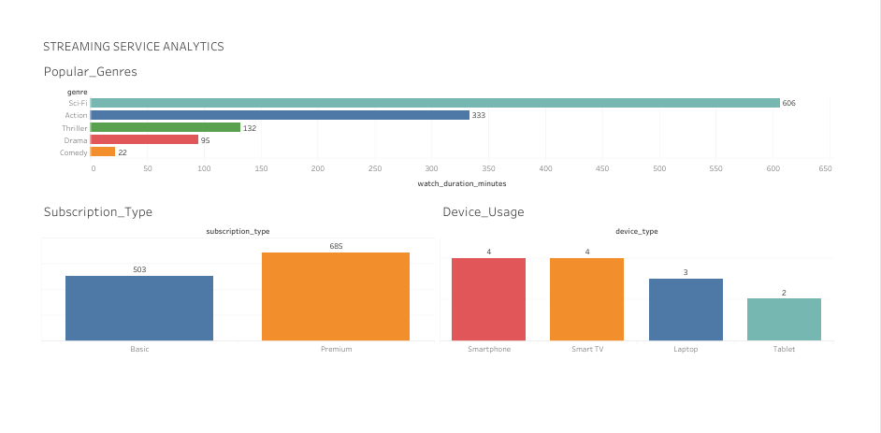
https://prod-ch-a.online.tableau.com/t/batuhandenizli-82d38b3220/authoring/SectoronCampusProject-StreamingPlatformAnalysis/Platform_Usage_Overview#1
(link)

